STM Complete
A great short-term major medical plan available to US citizens and
US legal residents. “Child alone” applications also accepted.

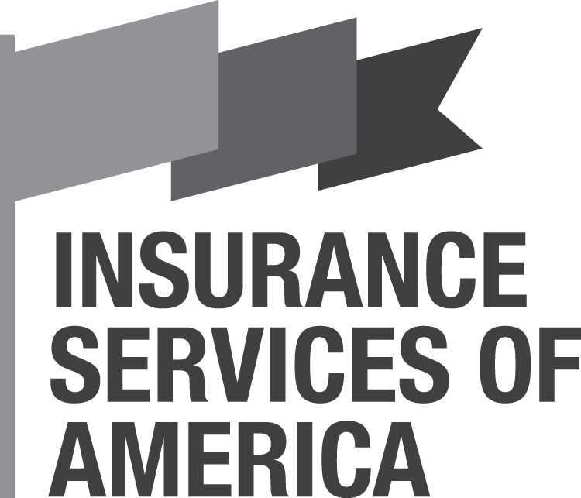
The STM Complete is an excellent short-term plan!

This versatile temporary medical insurance plan is perfect for clients awaiting ACA enrollment, those who wish to opt out of ACA – just about anyone up to age 64 looking for a lower-cost health insurance.

Graham Bates ›› graham@isabrokers.com
Alyssa Wright ›› alyssa@isabrokers.com
Suzanne Munson >> suzanne@isabrokers.com

Phone ›› (800) 647-4589 – (480) 821-9052 (local)

www.ISAbrokers.com

Contact Us Today with Questions
STM Complete is ideal for:

US citizens or legal residents between ages 2 and 64 needing temporary health coverage.

This plan is available in AK, AL, AR, AZ, DC, DE, FL, GA, HI, IA, ID, IL, IN, KS, KY, LA, MI, MO, MS, NC, NE, NV, OK, OR, PA, SC, SD, TN, TX, WA, WI, WV, and WY.
Your Market
The Facts
March 2017

The Top 6 Reasons
Why You Should
Sell This Plan

- A+ Superior rated carrier

- NO Decline Question!
The “Have you been declined for insurance?” question is not on the application so more applicants are eligible for coverage than ever before! Plus the other health questions are fewer and more liberal

- Only a $50 co-pay at any urgent care facility (then 80% or 50% to $5,000)

- Low rates with no add-on association fees to increase the price! (except in CA, CO, CT & IA – then only $.17 per day).

- 80%/20% to $5,000 stop loss (not $10,000 like other plans)

- No SS# required. We insure any legal US resident ages 2 to 64

